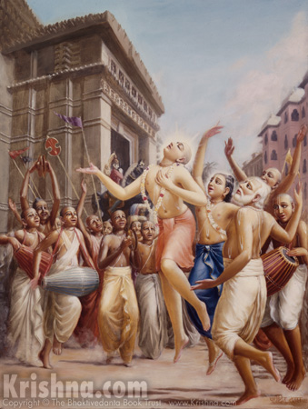
Soldiers of Godhead
September 2011
www.soldiersofgodhead.yolasite.com
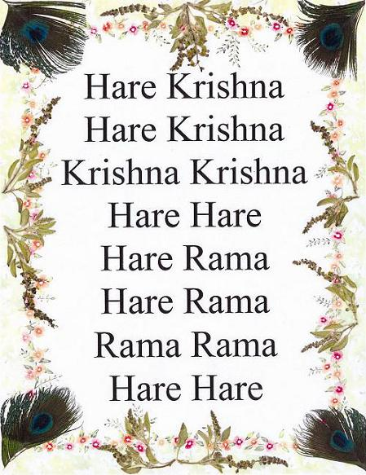
Chant Hare Krishna and be Happy!
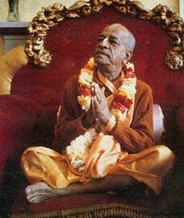
Dedicated to His Divine Grace
A.C Bhaktivedanta Swami Prabhupada-Founder Acharya of the International Society for Krishna Consciousness.

Message of the Acharya
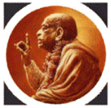 “What is the duty indicated by Krishna? Mad-yājī māṁ namaskuru. Even if we are not inclined to obedience, we must obey and offer respects (namaskuru). Bhakti, or devotion, minus respect is not bhakti. One should engage in Krishna consciousness with love and respect and should thus fulfill his designated duties. Then life will be successful. One can never be happy by identifying himself with the material body and engaging in all kinds of nonsensical activities. For happiness, there must be consciousness of Krishna; that is the difference between spiritualism and materialism. The same typewriter, dictation machine, tape recorder, mimeograph machine, paper, ink, the same hand—on the surface, everything is the same, but everything becomes spiritualized when it is used in the service of Krishna. This, then, is spiritual. We should not think that something has to be uncommon to be spiritual. The entire material world can be transformed into spirit if we simply become Krishna conscious. By ardently following the instructions of Krishna in Bhagavad-gītā and following in the footsteps of the great ācāryas, teachers of Bhagavad-gītā in the line of disciplic succession, we can spiritualize the earth and restore its inhabitants to sanity.”
-His Divine Grace A.C Bhaktivedanta Swami Prabhupada- Founder Acharya of the International Society for Krishna Consciousness.

Contents
Sr.no Topic Page no.
- Harinam Sankirtan 8.

- The World is Real. 14.

- Karmic Food. 19.

Becoming Hindu and Finding the Essence of All Spiritual Paths. 22.

Scientific Proof of the Soul. 32.

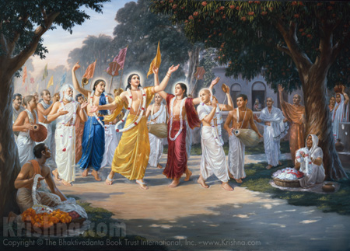
Sri Krishna Chaitanya Mahaprabhu inaugurated the Harinam Sankirtan Movement in the 15th Century A.D in West Bengal, India.

- Harinam Sankirtan.
Krishna is the Supreme Personality of Godhead. This simple yet profound truth is confirmed by authorized Vedic Scriptures like Srimad Bhagavatam, Srimad Bhagavad Gita, The Brahma Samhita, Padma Puran, Garud Puran, to name a few. Also, Vedic authorities like Lord Brahma, Srila Narada muni, Srila Vyasadeva, Srila Madhavacharya, Srila Ramanujacharya, Srila Vishnu Swami, Srila Nimbarkacharya, and even Sripada Adi Shankracharya have accepted Krishna as the Supreme Absolute Truth.
In Bhagavad Gita 9.14 Krishna states- satatam kirtanyanto mam yathanthas ca drid vrata “with great determination always engage in chanting my names and glories.” Thus, through this verse Krishna has emphasized on the process of chanting His holy names and glories. It is stated in the Brihad Naradiya Purana-
harer nama harer nama harer namaivam kevalam
kalau nastey eva nastey eva nastey eva gatir anyatha
“Only by chanting the holy names of Lord Hari, Only by chanting the holy names of Lord Hari, and Only by chanting the holy names of Lord Hari can one achieve perfection in Kali Yuga. There is no other way, there is no other way, there is no other way.”
Krishna is also known as Hari meaning ‘he who redeems’ or ‘he who grants liberation’. So those who desire liberation from material bondages of repeated birth, death, old age and diseases are advised to engage in chanting the holy names of Lord Hari or Krishna in order to get free from all material bondages. Chanting names or worship of demigods or pseudo god men will not help as is indicated by the words nastey eva gatir anyatha “there is no other way.”
The Kali Santarna Upanishad states-
Hare Krishna Hare Krishna Krishna Krishna Hare Hare
Hare Rama Hare Rama Rama Rama Hare Hare
iti sodashakam namnam kali kalmasha nashnam
nataha parataropayah sarva vedeshu drishyate
“By chanting the sixteen words Hare Krishna Hare Krishna Krishna Krishna Hare Hare/Hare Rama Hare Rama Rama Rama Hare Hare, all the ill effects of the age of Kali are destroyed. No other method is to be found in all the Vedic Scriptures.”
The above statement clearly emphasizes the chanting of the Hare Krishna Maha mantra. Krishna is the Supreme Absolute Truth. Therefore there is no difference between Him and His names, His qualities, His activities, His paraphernalia, His body, His senses, His mind, etc. Everything associated directly or indirectly with Krishna is also Krishna. This is His inconceivable absolute nature as is confirmed in the Brahma Samhita by Lord Brahma himself.
Krishna states in the Bhagavad Gita that whenever and wherever there is a decline in religious practice, He descends to make things right. In Kali Yuga there is a great decline in religious principles. People of Kali Yuga are short lived, they have reduced memory and intelligence, they are bereft of austerities, mercy and cleanliness. Hence, the sacrificial ceremonies, austerities, and other processes mentioned in Vedic scriptures are not practical for the people of Kali Yuga. The practice of meditation is very popular in certain traditions and various yoga societies around the world. But this sort of meditation is not recommended for Kali Yuga. Meditation was the recommended method for achieving liberation in Satya Yuga or the Golden Age. Sacrificial methods were practical in Treta Yuga or the Silver Age. Pilgrimages, Temple Worship and other austerities were recommended for Dwapar Yuga or the Bronze Age. However, in Kali Yuga (the Iron Age) because of upsurge in sinful activities of the human society, these sorts of sacrifices, austerities and penances are not practical for the general population. Hence, the Vedic Scriptures declare the process of chanting the Holy names of the Supreme Lord Sri Krishna (who is non-different from His holy names) as the recommended method of worship for Kali Yuga.
In order to practically demonstrate the process of chanting the Holy Names of the Lord, Sri Krishna Himself incarnated as Sri Krishna Chaitanya Mahaprabhu in 15th century A.D in Mayapur, West Bengal, India. Lord Krishna’s descent as Sri Chaitanya Mahaprabhu is confirmed in Vedic Scriptures like Atharva Veda, Srimad Bhagavatam, Garuda Purana etc. Sri Chaitanya Mahaprabhu appeared in the form of a devotee in order to preach to the people of Kali Yuga that only by chanting the holy names of Lord Krishna can one attain the highest perfection of going back home, back to Godhead. He inaugurated the Harinam Sankirtan Movement along with His confidential associates publically chanted Hare Krishna Hare Krishna Krishna Krishna Hare Hare/Hare Rama Hare Rama Rama Rama Hare Hare and spread the holy name of Lord Krishna across the Indian Subcontinent. He predicted that one day His “commander in chief will appear and spread Krishna Consciousness around the World. Krishna’s names will be chanted in every city, town and village around the world.” This prophecy was fulfilled 500 years later in 1966 by His Divine Grace A.C Bhaktivedanta Swami Prabhupada when He went to America to spread Krishna Consciousness and established the International Society for Krishna Consciousness (ISKCON) in New York which within a short span of 12 years grew into a worldwide confederation of over 108 Temples, farm communities, Ashrams, Institutes, etc.
Srila Prabhupada spread Krishna Consciousness in six continents and popularized the chanting of the Hare Krishna Maha mantra. The Harinam Sankirtan Movement came to be known as the Hare Krishna Movement and it continues to grow till date. The process of Krishna Consciousness is simple and sublime. By chanting the Hare Krishna Mahamantra all material dust covering the spiritual consciousness of the soul are cleared and the living entity is restored to his original consciousness. The transcendental vibration of the Holy names of Lord Krishna is equally appealing to everyone since it comes from the depth of the soul. Thus, engage in chanting the Holy names of Lord Krishna and experience the bliss of associating with the Supreme Lord Krishna Himself in the form of His holy names.
Hare Krishna!

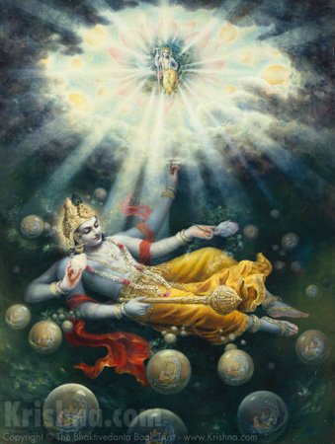
The material world is subject to repeated creation and destruction, therefore its manifestation is temporary and not false as is claimed by people with a poor fund of knowledge.
2.The World is Real.
We often think from where has this material world come from? Looking at stars, discovering new planets and galaxies has always fascinated human society. When scientists are asked “how was the world created?” they reply “it came from an explosion called the big bang.” Then a simple question that comes to the mind of every sane individual is “what existed prior to the explosion?” An explosion cannot come from nothing! There has to be some material substance which led to the explosion. Therefore, the conclusion is that the “Big Bang” was not the beginning of everything since something surely existed before the explosion which led to the explosion if at all it ever happened. The scientists, scholars, philosopher and so called intelligentsia have been speculating about the creation of the material world since the last century and their present and future research are based on models of theories which are based on unrealistic assumptions. Such defective knowledge cannot give us precise and accurate information about the creation of the material world.
When the same question is posed to various religious groups, they say that God created the world in a week’s time, some state that the world is false and is a product of maya (illusion) and only the spirit soul is the ultimate reality and so on. Thus, even the various religions or spiritual paths of Kali Yuga are not able to answer the basic question of wherefrom the material world has come.
The revealed Vedic Scriptures like the Vedas, Upanishads, and Puranas give us precise, accurate and definite information about the creation, maintenance and destruction of the universe. The Srimad Bhagavatam describes the process of creation in the most authentic manner. Lord Krishna is the Supreme Personality of Godhead and He eternally resides in His eternal abode Goloka Vrindavan with His devotees and confidential associates. There the living entities enjoy eternal life of freedom from birth, death, old age and diseases, freedom from hunger, thirst, lust and miseries. They engage in transcendental pastimes in the association of the Supreme Lord Sri Krishna. But, when the living entities desire to enjoy remaining independent of Krishna and compel Krishna to create the material world where they can enjoy sense gratification, Krishna like a father who gives in to the tantrums of his children begins the process of creation of the material world for the living entities.
He expands Himself as Karnodakshayi Vishnu or Maha Vishnu and the material universes emanate from the pores of His Transcendental body. Further, He impregnates material energy Maya with the seeds of the living entities. He further expands Himself as Garbhodakshayi Vishnu and enters into each universe to look after its maintenance. Further, He expands as Kshirodakshayi Vishnu and enters into each and every atom of the material world and into the heart of every living entity be it an ant, a microbe, a beast, a human or demigod. In this way Krishna through His various expansions is all pervasive. In every universe, Lord Brahma who appears from the navel lotus of Lord Garbhodakshayi Vishnu creates the 8.4 million species of living entities and the various material planets. Lord Brahma lives for a period of 100 years. His 12 hours are equivalent to our 4.3 billion years and his one day is equal to our 8.6 billion years which is known as a Kalpa. His month has 30 such days and his one year has 12 such months. Therefore, Brahma’s life time is inconceivable to the tiny human brain.
On the completion of his day all material planets, living and non living things are destroyed and the living entities (spirit souls) rest in the body of Garbhodakshayi Vishnu and they become manifest on the next day of Brahma when he again creates the material world.
These transcendental subject matters are inconceivable to the ordinary living entities but there is a precise description of this in the authoritative Vedic Scriptures. The mayavadi philosophers like Buddhists and Advaita Vedantists claim that the material world is a product of maya or illusion and is thus false. However, the Vedic scriptures disagree with them. The material world is a product of the material energy of Krishna. And nothing associated with Krishna is false. The material energy is eternal but its manifestations are temporary. And the living entities being the marginal energy of the Lord are superior to the material energy, but owing to our desire for sense enjoyment we have become subordinate to the material energy. This is not the natural position of the living entity. Hence, the living entities are engaged in a struggle for existence in the material world and are unable to find happiness, peace and satisfaction in spite of so many advancements in the field of science and technology and accumulation of wealth and power. The Supreme Lord Sri Krishna descends in His various incarnations to make the living entities understand their true spiritual position. He is eager to see the living entities come back to His eternal abode Goloka Vrindavan which is transcendental to the material universe and not subjected to creation and destruction. Lord Krishna explains in the Bhagavad Gita that it is only by surrendering at His lotus feet that the living entities can achieve liberation from material miseries. Devotional Service to Lord Krishna is the only way by which the living entities can go back home, back to Godhead.
Hare Krishna!


Those who eat abominable things like non vegetarian food, fast foods or even vegetarian food which is not offered to Krishna are eating only sin.

3.Karmic Food.
Krishna says in the Bhagavad Gita 9.26 patram pushpam phalam toyam yo me bhaktya prayachte “if someone offers Me with love and devotion even a leaf, a flower, a fruit or even a little water, I accept it.” Thus, Krishna specifies what He desires as offerings from His devotees and what He desires His devotees to eat. Krishna asks for leaves, flowers, fruits and similar pure vegetarian items. He does not ask for abominable things like non vegetarian foodstuffs like eggs, fish, meat, flesh etc. The Vedic Scriptures declare bhajante te tv aghama papa ye pachyante atma karanat “those who eat food only for their personal sense enjoyment, eat only sin.” Thus, food cooked only for one’s own sense enjoyment and not for Krishna’s enjoyment will lead only to sin. Therefore, food must be cooked with the intention of first offering it to Krishna and pleasing Him. But the condition is that the food must be pure vegetarian (even onion, garlic and red lentils must be avoided) and must be prepared and offered to the Lord with Love and Devotion. By offering food first to Krishna, Krishna mercifully accepts the offerings no matter how humble it maybe and this sanctifies the food and such food is technically called ‘prasadam’ or ‘mercy of the Lord’. This, prasadam must be eaten by the devotees and distributed among everyone. The benefit of eating Prasadam is that it does not involve any karma, therefore it does not further the material entanglement of those who eat it. Instead, it sows the seeds of devotion in the heart of those who eat it.
On the other hand, those who cook or eat food only for their personal sense enjoyment are furthering their material entanglement. It is stated in Vedic Scriptures that the state of mind in which one cooks food, the same is invested in the food cooked and all those who eat that food are going to be affected by the contamination. This occurs at a very subtle level so it is not easily or immediately noticeable. Also, if the cook has sinful habits, or has committed sinful acts, or has sinful desires or intentions, then the same is invested in the food cooked by him/her. Such food is called ‘Karmic food’. And when such food is eaten by others, these sinful tendencies are subtly transferred into them thus spreading like an infection. However, when the food prepared is first offered to the Lord (it must be pure vegetarian) even if it contains any such contamination, such contaminations are neutralized by Krishna’s mercy and He accepts the humble offering made by the devotee.
Following are some of the effects of Karmic food:-
- Increasing material attachment.
- Increasing desires for sense gratification.
- Reduction in memory and intelligence.
- Reduction of life span.
- Development of sinful tendencies like intoxication, meat eating, illicit sex, gambling etc.
- Increase in diseases and disorders.
- Development of dislike towards spiritual subject matters.
The above are only a few of the many ill effects of Karmic food. The dangers of consumption of Karmic food are many, but the same can be avoided by consumption of Krishna Prasadam. By consuming Krishna Prasadam or food sanctified by Lord Krishna, one achieves purity of mind and body, development of devotion for the Lord, development of good qualities, desires for spiritual progress, desire to associate with the devotees, increases longevity and much more. Thus, by cooking food for Krishna’s pleasure and eating only Krishna Prasadam one purifies his existence, develops love and devotion for Lord Sri Krishna and goes back home, back to Godhead.
Hare Krishna!

4. Becoming Hindu and Finding the Essence of All Spiritual Paths

Source: ISKCON News.
By Radhanatha Swami for Huffington Post on 2 Sep 2011
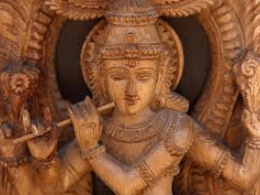
The tension between the essence of spiritual teachings and the harmful fundamentalism that often arises in the name of religion is an issue that has engaged my mind practically as far back as I can remember. I recall in my childhood asking, "How is it that hatred could fester in the name of a loving God?" Experiences of religious discrimination had traumatized my young, impressionable mind. Whereas religious prayers sing of peace and harmony, religion has divided human beings through an atrocious history of enmity and bloodshed. Yet, behind the veil of superficiality and hypocrisy, I always believed in the inherent beauty of God that lies at the essence of all true spiritual paths.
This childhood intuition of mine would become a guiding principle in my life and eventually shape my future in ways that I could never have imagined. As a 19-year-old, I set off on a journey to find God. On a path fraught with danger, I hitchhiked from Europe through Turkey, Iran, Afghanistan and Pakistan. After six months I arrived at the Indian border haggard, sickly and covered in dust. I was a penniless pilgrim, but full of excitement in anticipation of the riches of wisdom lying just beyond this final hurdle. Naively, I handed my passport to the boarder guard. "How much money do you have?" I had 26 cents. "We have enough beggars, go back!" she replied. For six hours I pleaded. For six hours I received verbal assaults, threats and rejection until, after the changing of the guard, a sympathetic Sikh gentleman finally relented and allowed me entrance. For me, it would be an entry not only into the nation of India, but also into a vast spiritual tradition -- rather, a fusion of traditions, commonly known as Hinduism. This would serve to develop my understanding of the world and my place in it, and radically transform nearly every aspect of my life.
What I found particularly fascinating and satisfying about the Hindu tradition was its spirit of inclusiveness. In Sanatan Dharma, or what is commonly called Hinduism, I discovered the basic truths of all religions in a way that the oneness of God and religion is comprehensively understood. This is not just as a sentimental idea, but is based on philosophical, theological inquiry accompanied by a scientific practice. The essential Hindu scriptures elaborately describe the nature and qualities of God and the divine spiritual realm. I discovered fascinating explanations of the soul, the material world, the causes of suffering and a variety of practices meant for the soul's liberation. And interestingly enough, I found that this knowledge not only opened the doors to a sublime spiritual path, but also granted a profound insight and appreciation into other religious traditions. I felt this to be critical in a world torn by sectarian views.
The essence of Hinduism is the same essence of all true religions: Bhakti or pure love for God and genuine compassion for all beings. Why should we fight over which religion is better? It is pointless. True love for God devoid of selfishness or egoism is the best religion. Wherever true love, broad mindedness, integrity and compassion are present, there one will find real religion through whichever path it is realized.
I don't mean to paint too rosy a picture. The past four decades I've spent immersed in Hindu culture have shown me not only broad-minded inclusiveness, but also the same kind of shallow fundamentalism that can be found in any religious group: sectarian pride, attachment to the external aspects of form and ritual while missing their very purpose, and narrow-minded allegiance to a tradition without embracing its spirit of universal love and compassion.
Forty years ago, that kind Sikh gentleman opened a door to a spiritual quest by allowing me entrance into India. That brought me into the presence of many saints and spiritual leaders. Some of these people claimed a monopoly on God, condemning other forms of worship as pagan, heathen, idolatrous, satanic or heretic. Most devoted people I met, however, honored other faiths and helped me see the common essence lying beneath apparent contradictions.
If we probe beyond the often-contentious histories of world faiths and examine the essence of their teachings, we can find a common foundation that unites the various visions of God. A famous parable underscores this common foundation by comparing visions of God to parts of an elephant. A holy person came with his elephant to a remote village that was suffering from severe drought. On the back of the elephant he brought a large vessel of fresh water to the home of six blind men who always stuck together to help each other, but somehow always quarreled. After the water pot was lowered from the elephants back, down to the ground, the first blind man reached out and caught hold of the elephant's tail. "The elephant," he declared, "is like a piece of rope."
The second man grabbed an ear and said, "No, the elephant is like the leaf of a banana sapling."
The third man was holding the trunk and said, "Wrong. The elephant is very much like a huge snake."
The fourth man had his arms around one of the elephant's legs. "What nonsense are you talking!" he exclaimed. "It is definitely like a pillar."
"Wrong," cried out the fifth blind man, clinging to a tusk. "You are all misled. The elephant is certainly like the branch from a magnolia tree."
The sixth man, rubbing the elephant's belly, said, "Can't any of you see? It's obvious the elephant is like a sack of grains."
Soon a quarrel erupted between them. While they were on the ground punching and tearing each other's hair, they rolled right into the water vessel. All the water spilled out onto the ground while the elephant stood by looking on with an expression of pity.
Of course, each of the blind men was partially correct, and their fighting was pointless, since they were describing the same object. The elephant came to the starving men to provide water. In their useless debate, they missed the benefit. Similarly, God reveals different visions of Himself according to the needs of time and place for the purpose of giving us the water that will quench our thirst for love and happiness. Throughout history, declaring one vision all in all has been a convenient pretext for aggression, as it is relatively simple to manipulate uneducated or insecure people with propaganda. It is unfortunate to see that God, whom all faiths exalt as great, is so often depicted as small, petty and partial to one group.
Recently I was reminded of my initial entry to India, when I was granted the privilege of an audience with India's president, Pratibha Patil. I had to smile, recalling how dramatically things had changed in my life since my first entry to India. Four decades had passed and as much as my life had transformed, so had my reception. Unlike the border officials who had rudely rejected me, India's top security personnel greeted me with folded palms and cheerfully escorted me through a series of checkpoints.
Ceremoniously, they brought me directly to the President who stood to greet me with a warm, gracious smile and a basket of fresh fruits. I found President Patil to be a modest woman of culture and integrity. Our discussion was meaningful and like so many people I meet, both in India and abroad, she posed a familiar question. "As an American who has studied and experienced many of the world's religions, why did you choose to follow Hinduism?" I honestly revealed my heart, expressing my genuine appreciation for all the great religions of the world and my belief that one could attain a spiritual perfection by properly following any of them with honesty and sincerity.
My childhood conviction that the inherent beauty of God must lie at the essence of all true spiritual paths has only grown over the years. Of course, the accounts of tragedy in the name of God have endured as well. Whenever I hear such unfortunate news, I can't help but think that perhaps a prudent addition to the premise of God's greatness would be that God is greater than our comprehension of Him -- greater even than the religions we dedicate in His honor. God is independent and not restricted by our expectations or demands. This is the premise of the Bhakti tradition and the starting point of the journey to reawakening our love of God: God is so much bigger than we imagine.
I enjoyed the honor of meeting President Patil and felt that she was genuinely moved by my appreciation for her culture and people. And I find it somehow pleasantly ironic that, in answering her question, "Why did you chose to follow Hinduism?" the answer would lie in how this one religious tradition has helped me see the truth and beauty of all the rest.

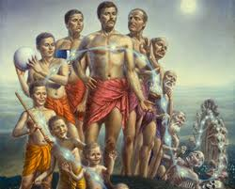
The temporary material body is undergoing constant changes in the form of birth, infancy, childhood, youth hood, adulthood, old age and death. Even while undergoing these bodily changes, the spirit soul remains as it as and after death of the body, the soul transmigrates to another body and the cycle of repeated birth and death thus continues in the material world.
5.Scientific Proof of the Soul.
The following conversation between His Divine Grace A.C. Bhaktivedanta Swami Prabhupada and an Indian doctor took place in September 1973 at the Hare Krishna center in London:

Doctor: Can you scientifically prove that the soul exists? I mean, is it purely a matter of belief, or --

Srila Prabhupada: No, it is a scientific fact. Our science is perfect, because we are receiving knowledge from the perfect source, Krishna. And modern so-called science is imperfect, because the scientists' knowledge is received from imperfect sources. However great a scientist you may be, you have to admit that your senses are imperfect.

Doctor: Yes.

Srila Prabhupada: So, imperfect senses can give only imperfect knowledge. What you are calling scientific knowledge is bogus, because the men who have produced that knowledge are imperfect. How can you expect perfect knowledge from an imperfect person?

Doctor: It's a question of degree.

Srila Prabhupada: My point is that if you are unable to give perfect knowledge, what is the use of taking knowledge from you?

Doctor: Yes, I accept that view. But how do you prove that the soul exists?

Srila Prabhupada: You take information from the perfect source, Krishna, or from Krishna's representative, who repeats the words of Krishna. That is our process of proof. Evam parampara-praptam:
"Transcendental knowledge must be received in disciplic succession." We don't accept knowledge from a rascal; we accept knowledge from Krishna, the Supreme. I may be a rascal, but because I am receiving knowledge from the perfect source and repeating that, whatever I say is perfect. A child may be ignorant -- he does not know what is what -- but because he has learned that a certain article is called "table," when he says "Father, this is a table," his words are perfect. Similarly, if you hear from the perfect person and believe that, then your knowledge is perfect. Krishna says tatha dehantara-praptih: "After death the spirit soul enters another material body." We accept it. We don't require proof from a so-called scientist, who's imperfect.

Doctor: So the question of belief comes first.

Srila Prabhupada: It is not belief; it is fact.

Doctor: Yes, but how do you prove that fact?

Srila Prabhupada: That Krishna says so is proof.

Doctor: [very sarcastically] "It has been said by Krishna." But --

Srila Prabhupada: That is our Vedic proof. Whenever we say something, we immediately quote from the Vedic literature to support it. This is our process of proof, which is just like that in the law court. When a lawyer is arguing in court, he must quote from previous judgments. Then his argument will be accepted by the judge as legal proof. Similarly, as soon as we say something, we immediately support it by quoting from the Vedic literature. That is the way of proof in spiritual matters. Otherwise, what are the scriptures for? If they are merely products of mental speculation, what is the use of these books?
Of course, the Vedic literature also presents the Absolute Truth with all logic and reasoning. For example, in the Bhagavad-gita (2.13) Krishna says,

dehino 'smin yatha dehe
kaumaram yauvanam jara
tatha dehantara-praptir
dhiras tatra na muhyati

"The soul is changing his body from childhood to youth and from youth to old age. Similarly, the soul enters another body at death." Where is the illogical presentation? This is scientific. For an intelligent man, this is scientific proof. And if he's still dull-headed, what can be done?

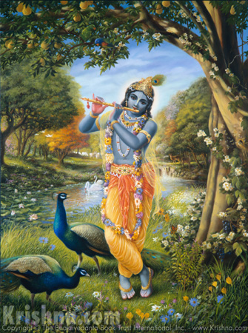
Dedicated at the Lotus Feet of Lord Sri Krishna the Supreme Personality of Godhead.

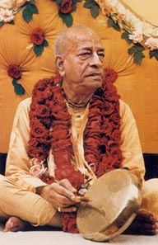
Dedicated to His Divine Grace
A.C Bhaktivedanta Swami Prabhupada- Founder Acharya of the International Society for Krishna Consciousness.

Written, Edited, Published and Distributed by Rasabihari Das (Vinay D Chakraborty).

Do send in your views, comments, suggestions or questions to vinay.chakraborty@yahoo.com

For more information please visit- www.soldiersofgodhead.yolasite.com

Chant Hare Krishna and be happy!

